Palomar Council
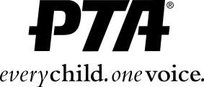

School Name
Unit Report
Date of Monthly Meeting

Information Items:

- List info here about what you are doing at your unit on your school site.

- Sometimes there’ll be a theme I’ll ask you to talk about, like best practices, how your volunteership’s shaping up, etc.

- Any questions you have can go here, too.

Out and About:

List here where you’ve been on PTA business.

Hours:

Putting your hours here will help our Historian greatly!

Submitted by: Your Name Here, Unit President

